## Milestone 3:

Our site can be viewed at: <insert LINK>

## Items Completed for this Milestone:

* Base CSS created for site
  + Design implemented through flexbox
  + Forms designed
  + Tables designed
  + Layout finalized
* All pages created and written in HTML
  + Validated CSS, HTML, and Accessibility
* A/B testing of design elements

## Key Issues

We some difficulty creating a Stylesheet that would work for the multiple layouts we use on our site. It was somewhat difficult to try to reduce the number of classes we implemented in CSS. The balance of desired features and cross-compatibility was also difficult in the design phase.

## Deviations from initial design

We altered our design slightly to have a page wide banner, as after testing we felt we had a better response to the page-wide design. We changed the color palette slightly but maintained the theme for which we were aiming.

## Documentation:

Home Page:

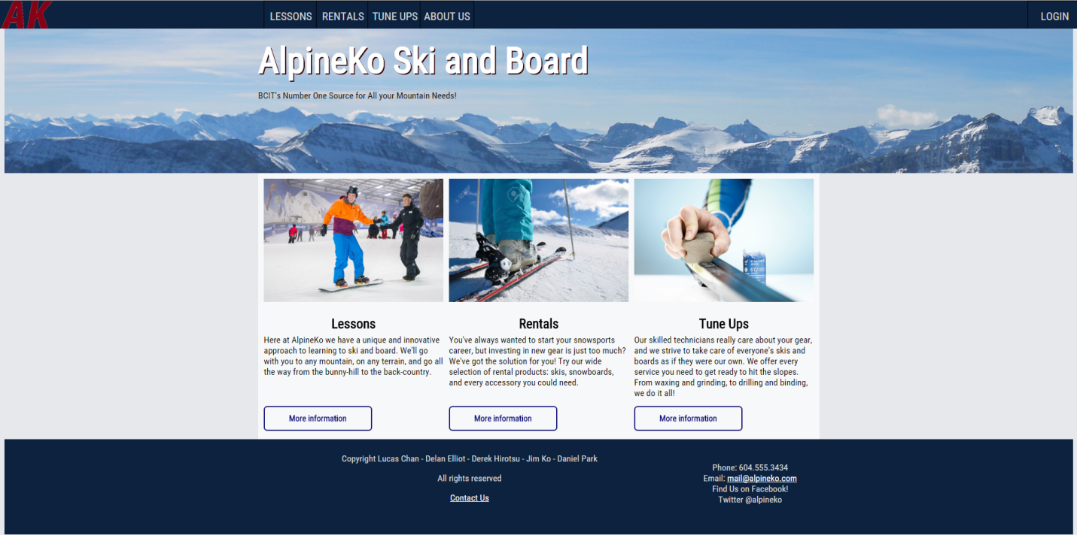

## A/B Testing:

**Home Page**

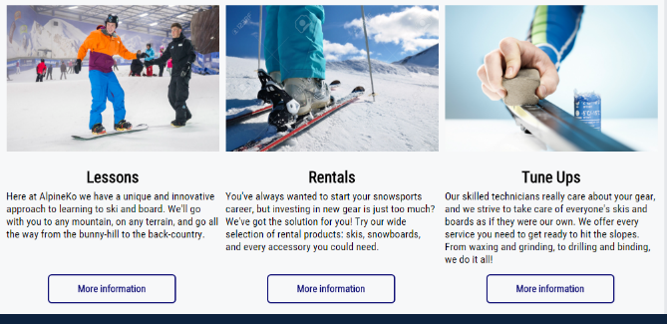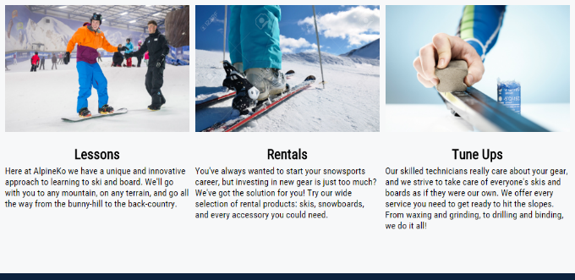

Tested for visual clarity of only clickable images versus buttons.

**Rentals Page**

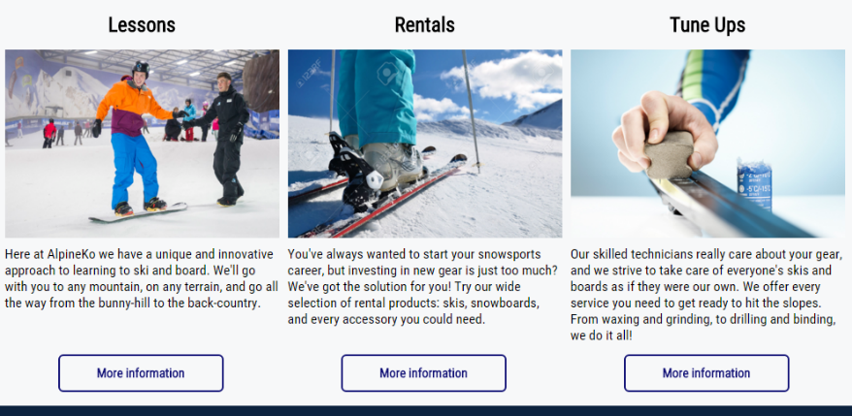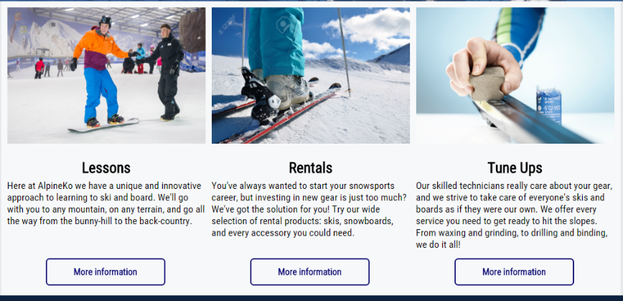

Tested for visual clarity in regards to having the headings above the images and separated from the body paragraphs versus having both the headings and the body together under the images.

**Lessons Page**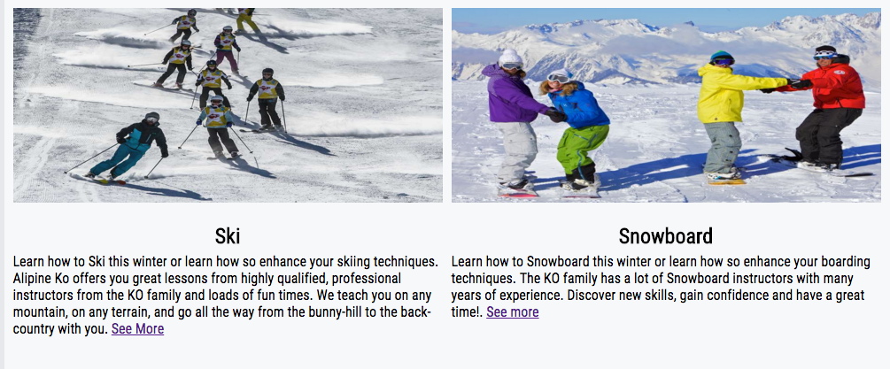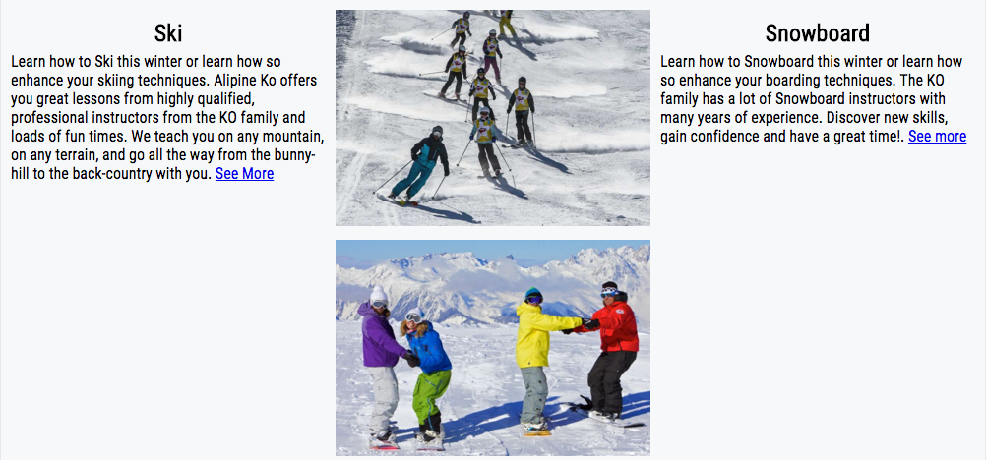

Tested visuals to see what would look more appealing to the user. The first one consists of only 2 divs the second one has 3 divs 1 is set for only the images.

**Skiing Lesson Page**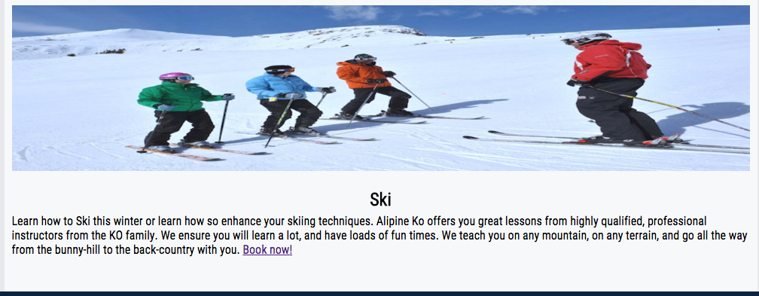

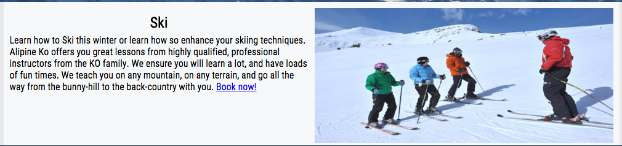

Tested making the image its own dev so it would sit next to the text compared to the image being above the text.

**Snowboard Lessons Page**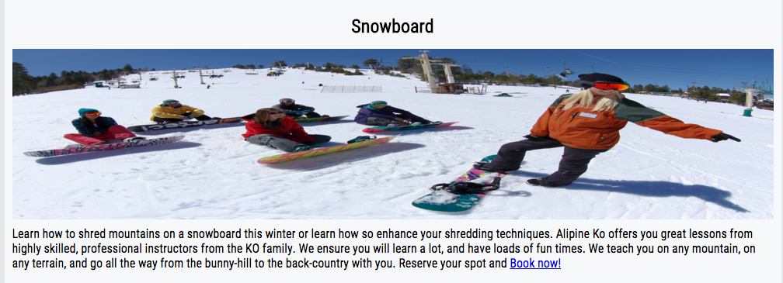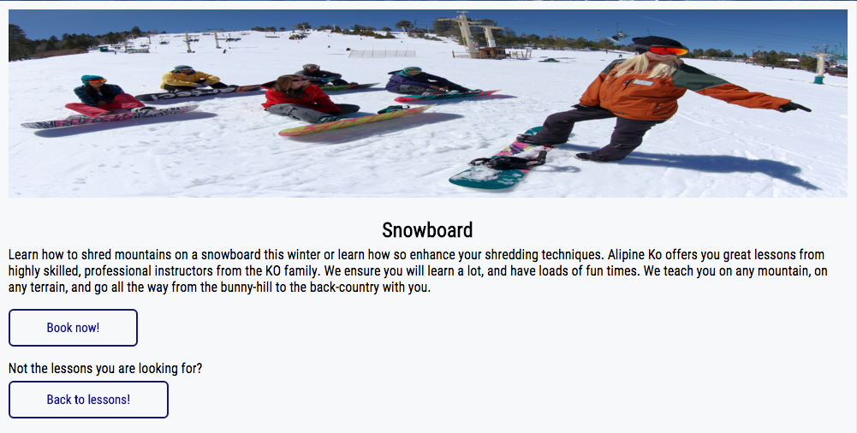

Added buttons to the book now! page and back to lesson! to make it easier for the visiter.

**Rental Booking Page**

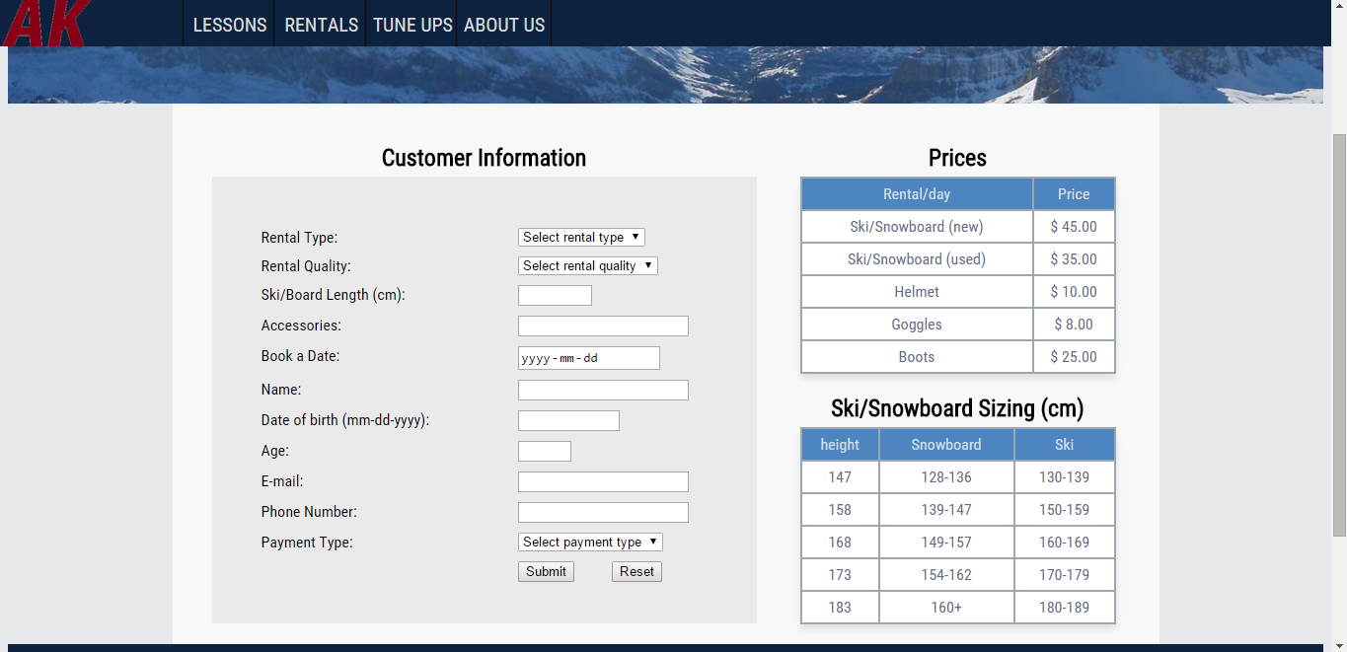

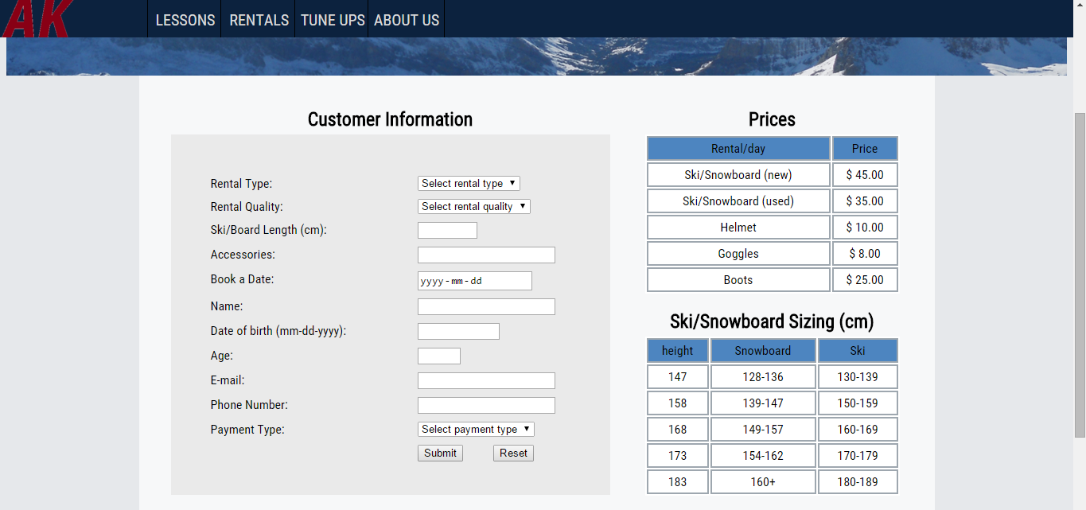

Tested two different tables to see which was more visually appealing. One table had a collapsed border, box shadow and grey font.

**Lesson Booking Page**

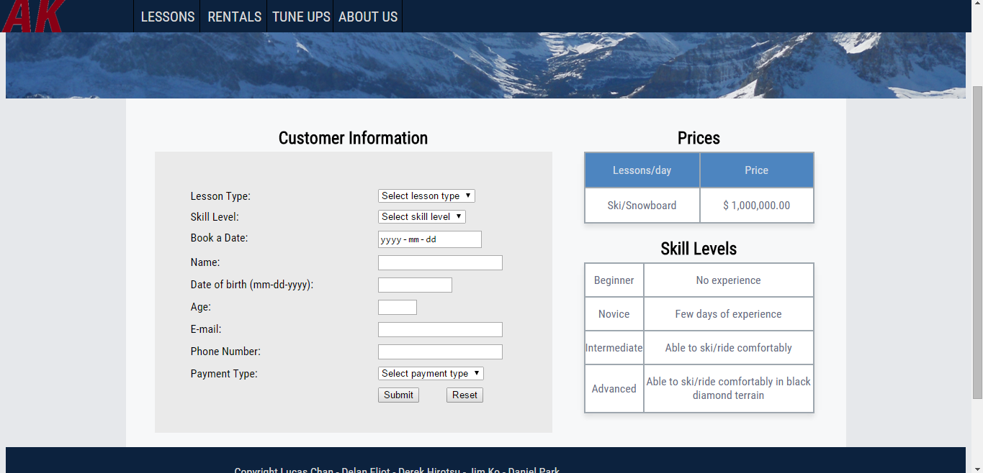

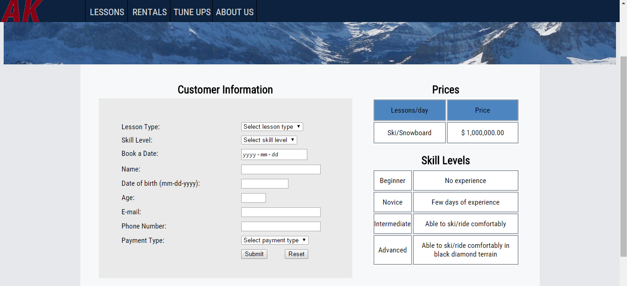

Tested two different tables to see which was more visually appealing. One table had a collapsed border, box shadow and grey font.